Practical Exam   
Fall 2019  
Subject: WED201c  
Duration: 120 minutes

**Background:**

In this practical exam, you are given a folder “**Resource**”. You are going to use three pages “index.html”, “history.html” and “teams.html” and “images” folder to finish the exam.

**Objectives:**

1. Create a style sheet and link it to the html files. **(Without changing the html)**

2. Style the sheet using the properties color, background-color, text-align, text-transform, and/or display, … to complete all these requirements

**Before styling index.html page**

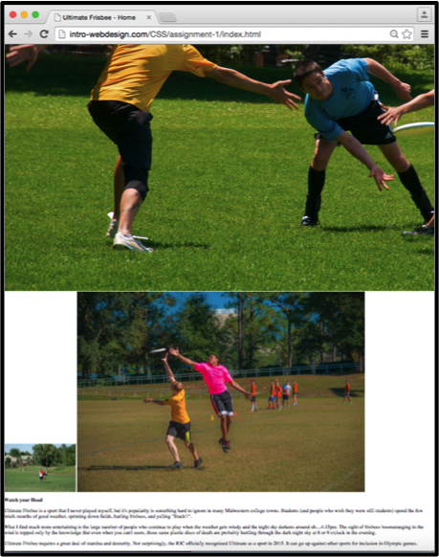

**After styling index.html page**

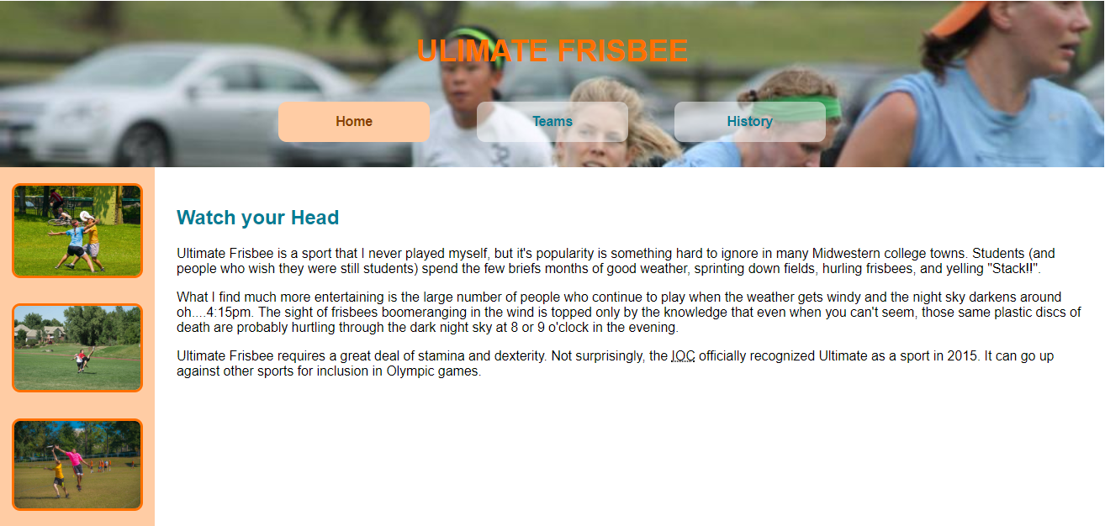

**After styling team.html page  
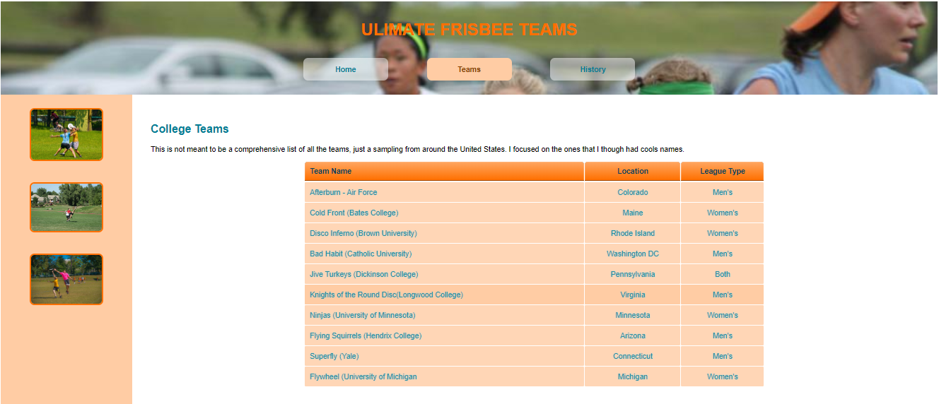**

**After styling history.html page**

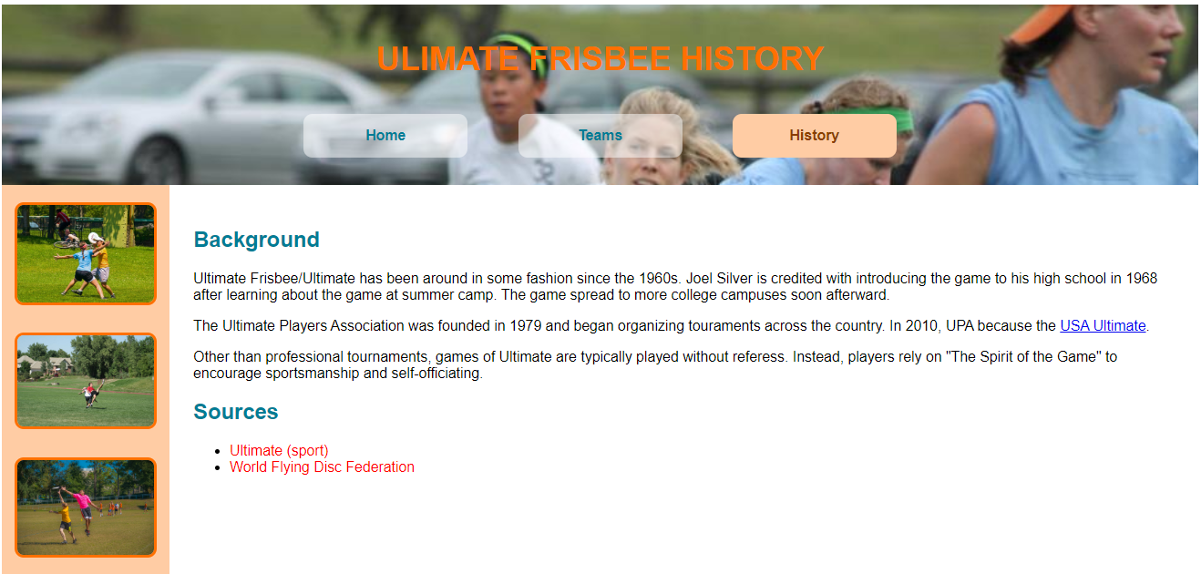

**Requirements:**

1. Create a file called **hw1.css** and save it in given **Resource/CSS folder.**
2. In file hw1.css, using the properties color, background-color, text-align, text-transform, and/or display, … to style three pages “index.html”, “history.html” and “team.html”. You can view the styled pages in folder “**template**”

**Evaluation:**

* Insert a background image into header tag (find this image in Resource/images folder) [1 point]
* Using some css properties to style aside tag and section tag (view html pages) to place these tags on the left and right side of its container. [3 points]
* Using the border properties to style images with any color [2 points]
* Apply some css properties to table tag in team.html page [3 points]
* Apply text properties to li tags in history.html [1 point]

Total: 10 points

**(Students do not change the path of all files in Resource folder)**

The End